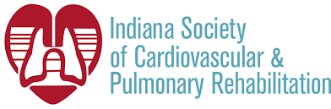

Table of Contents:
Nominations for BOD ISCVPR Annual Meeting
Benefits of being a Board member Website
National Meeting Review Social Media
Reimbursement Corner

Nominations to the ISCVPR Board of Directors
Susan Bauman, BSN, BC, CCRP
ISCVPR President
It is that time of year when we elect the ISCVPR Board of Directors for the next year. We are looking for members interested in expanding service to this society. Simply, complete the attached board application and return to Susan Bauman, President. We will contact you after your application is reviewed. The Board of Directors will be introduced at the annual conference. Feel free to reach out to Susan if you have any questions. She can be reached at susan.bauman@nwhealthin.com.
Thanks so much, Susan

Benefits of being an ISCVPR Board Member
Connie Wilson, RN
I have been an RN for 37 years and started my cardiac rehab career in 1991 and started my first pulmonary rehab program in 1994. I was invited by a board member that was in a hospital close to my program to attend an ISCVPR board meeting. The knowledge of the members and the passion that they had to help the profession grow. I joined the board then and served on the annual committee and as a board member. I was able to grow much faster in my profession because of the great mentors that were on the board. I have been through the ranks of leadership multiple times and still serve as a board member and the website chair. I left my position in cardiac rehab about 6 years ago, and was away for about a year, I returned about 6 years ago to my current position in cardiac rehab and started my second pulmonary rehab program. I reached out to my friends on the ISCVPR board when I went back, and they welcomed me back to the board. When I asked my current employer if they would support my role as a board member, they were very happy to oblige. You do not have to be head of a program to be a board member. If you are passionate about cardiac and pulmonary rehab, I would like to extend a personal invitation to reach out to me or any of our board members.

Reimbursement Corner
Susan Bauman, BSN, BC, CCRP; Cardiac Reimbursement Chair
Debbie Koehl, MS, RRT, AE-C, FAARC; Pulmonary Reimbursement Chair

As you may have already heard, President Biden informed congress this past Monday that he will end the twin national emergencies addressing Covid19 on May 11, 2023. How does this affect cardiac and pulmonary rehab? This will end the virtual home cardiac and pulmonary rehab coverage by CMS. The virtual Physician supervision allowance is scheduled to stay in place through the end of the year 2023. More information to come at the ISCVPR Annual conference in May.

More from the 2022 AACVPR Conference
Debbie Koehl, MS, RRT
I had the honor of attending the AACVPR with the support of the ISCVPR this past September 2022. Since my focus is pulmonary rehab, I spent the majority of my time in lectures regarding PR.
There were many interesting lectures that were thought producing and made me examine PR practices in general. Here are some tidbits of information I gleamed from the meeting.

- Pulmonary rehab is the only recommended therapy of the GOLD guidelines besides medications that can make a patient feel good and produce results.
- Medicare rules and regulations are always a challenge for PR programs!
- The effect of COVID-19 is going to be long felt and PR can be a useful tool for those patients.
- Finding fun ways to deliver staff competencies for both PR and CR makes it more rewarding for the staff.
- Everyone is trying to find ways to integrate psychosocial aspects into their delivery model. Use your resources available to you or find resources to refer patients to.
- Finding innovative ideas into getting your patients enrolled in PR. Utilize your EMR, Physician Offices and marketing.
- There was a great lecture on respiratory muscle dysfunction and the use of Inspiratory Muscle Training. The interesting aspect was that some cardiovascular patients had a higher respiratory muscle dysfunction than pulmonary patients. The lecture was very science and research driven with lots of cool graphs!
- Keep innovating your PR program. Had some great presentations on live virtual PR. The programs were successful, but they carefully picked their patients and had some very set guidelines to do this.
- And lastly PR billing and coding, making sure we are doing the right thing to get paid and for our patients.

Thanks again to the ISCVPR for supporting me, not only to attend but also supporting me when I was asked to provide a lecture on the PR Toolkit. (Don’t forget to get your copy off the website!)
Sarah Colias,RN,CCRP
I had the privilege of attending the AACVPR annual meeting for the first time in years. I attended the pre-conference titled “Anchoring and Sustaining Your Program: The Expert is Within”. This included discussions regarding reimbursement, program development, and ways to utilize the experts within your health care institution to assist one’s cardiopulmonary programming. Throughout the conference it was evident that we have strong leaders in AACVPR who are available and willing to share their experience and expertise in many areas such as how to run a hybrid program, intensive cardiac rehab, cutting edge exercise prescription, reimbursement updates, improving your ITPs, and the latest in the treatment of Heart Failure, SCAD, PAD, and POTS. This is just a short list of all that was offered at this meeting. As one who lives in the Chicago land area, I especially found a session regarding secondary prevention of diverse women with CV disease enlightening. A professor from the University of Illinois Chicago described a wellness program offered to the diverse, underserved neighborhoods of the city of Chicago. This program offers exercise, education, and affordable resources to this community. University staff and Physical Therapy graduate students give of their time to provide this much needed program. This was one of many sessions offered throughout the meeting showing how thinking outside the box and looking for ways to utilize available resources can help programs continue to provide our best patient centered evidenced based care.

ISCVPR Annual Meeting, 2023
Audrey Fuller, RN
Please save the date for the 35th ISCVPR Annual Meeting. We are happy to hold an in-person meeting once again in 2023 after two years of meeting virtually. This event will be held at the Wellington Fishers Banquet and Conference Center in Fishers, IN. The event begins Wednesday, April 19th, 2023, with Hors D'oeuvres and cash bar at 6:30 pm followed by the preconference from 7:00 pm-9:00pm. The conference will be held from 8:00 am-4:15 pm on Thursday, April 20th.This will be a wonderful opportunity to network with professionals from all over the state and includes the opportunity to receive several CEUs throughout preconference and conference. Hotel accommodations have been secured. Details are provided on the attached conference brochure as well as the ISCVPR website. Registration is now open.

ISCVPR Website
Connie Wilson, RN
Please take the time to go to ISCVPR.ORG and check out all the new information that we have been adding. The one resource that members have been asking for is an updated membership directory, so it is available and if you want a hard copy for your program you can print. Please use this great tool to find programs for your patients to return close to home. We have added the upcoming annual meeting brochure with a link to the meeting registration.

Social Media
Kim Clouse, BSBA, RRT, CPFT
ISCVPR news can now be accessed via Twitter @iscvpr, our Facebook page titled Indiana Society of Cardiovascular and Pulmonary Rehabilitation (not the acronym), and our iscvpr account on Instagram. We look forward to sharing updates in a timely manner including the 2023 the ISCVPR Annual meeting brochure.

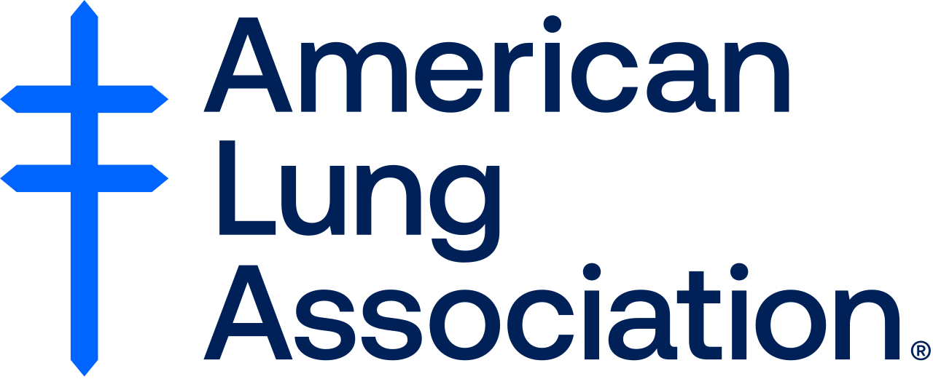

On behalf of the ISCVPR board members we wish you all the best as you prepare for the upcoming Cardiac and Pulmonary Week celebrations. Please forward pictures and stories of your week events. We would love to share them!
Sarah Colias, RN, CCRP; ISCVPR Newsletter editor

